Quick Start Guide – cascaded ff control loop instantiation.
The detailed guide for this process can be found in Supporting Documents in Section 10, below.
Definitions and Key Acronyms:
- PV: Process Variable(s)
  - PPV: Primary Process Variable
  - SPV: Secondary Process Variable
- DV: Disruptive Variable(s)
- SP: Setpoint
- CV: Control Variable
- PIDE: Proportional-Integral-Derivative Enhanced controller
- FBD: Function Block Diagram
- Bias: Preemptive adjustment to controller output based on anticipated process disturbances
- Objective: Work thru a specific example – Still01 LWC / LWVC Control Loop
  - Maintain vent condenser temp (TIT-4031) at 151–155 °F.
  - Condense ethanol while venting methanol via automated cooling control.

- Key Components
  - Primary PIDE (Outer Loop I Secondary PV (SPV)): Monitors TIT-4031; sets SP for inner loop.
    - SPV: TIT-4031
    - SP: 153°F (target midpoint)
    - CV: Sets SP for Inner Loop

  - Secondary PIDE (Inner Loop): Controls TIT-4033 by adjusting FCV-4032.
    - PPV: TIT-4033
    - SP: Provided by Outer Loop
    - CV: Cooling valve command (FCV-4032)

  - Feedforward Input: Adjusts valve CV based on PIT-4012 (vapor pressure), TIT-52001 (cooling temp), PIT-52006 (cooling pressure).
    - DV: PIT4012 (Vapor Pressure): Bias = 0.075 × Pressure (psi)
    - DV: TIT52001 (Cooling Temp.): Bias = 0.0086 × (Temp – 67.5°F)
    - DV: PIT52006 (Cooling Pressure): Bias = 0.25 – ((Pressure – 25)/70)
    - Total_Bias = Total Bias = 1 + PIT4012.bias + TIT52001.bias + PIT52006.bias
    - Note: Bias constants are historical starting points requiring regular validation and adjustment.
    - Important: Utilize Studio 5000 PIDE block built-in anti-windup features to prevent CV saturation. More on this topic here.

Architecture Diagram: simplified block diagram:
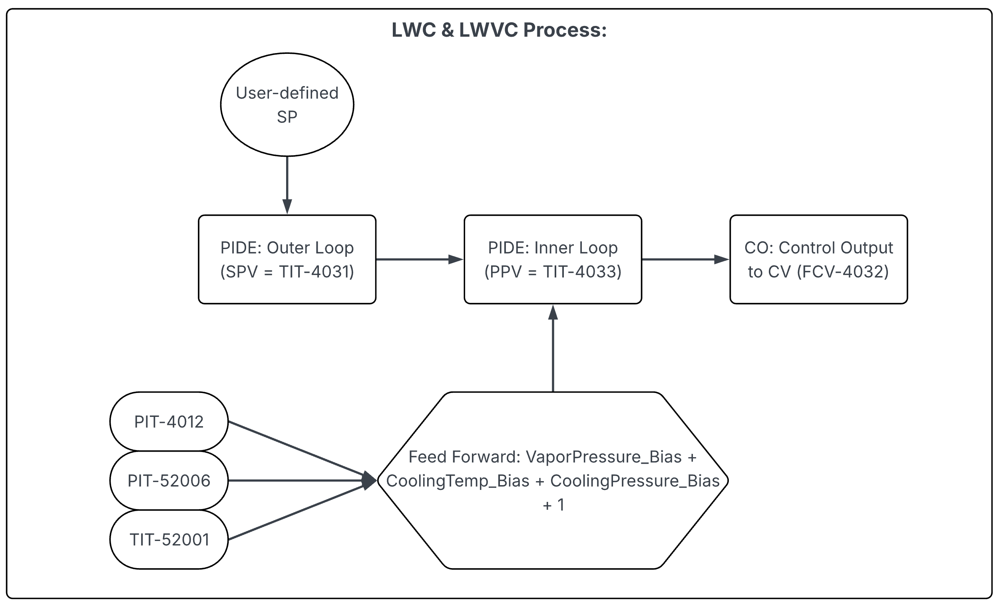

- Implementation in Studio 5000: PIDE Configuration (Function Block preferred)

  - Inner Loop: Periodic task @ 400ms, Priority: 5–7
    - SP Source = SPCascade input
    - Mode = CASCADE
    - Bias input wired to feedforward total
    - **Ensure: PV Input RPI < Task time (recommend 100ms)

  - Outer Loop: Periodic task @ 1.8s, Priority: 8–10
    - CV = Inner Loop SP
    - Mode = CASCADE
    - CVInitReq logic for manual transitions
    - Feedforward Wiring:
      - Use SCL blocks to scale PIT-4012, TIT-52001, and PIT-52006
      - Combine into a single Bias signal and clamp it if needed
  - NOTE: Task Scheduling & Timing: Place each PIDE instruction in separate periodic tasks to allow independent adjustments. Collect and use baseline response data (worksheet provided) to refine these intervals.

  - Scheduling best practices:

    - Outer loop must update after inner loop in same scan.
    - In FBD, execution order is preserved left to right.

- Tuning Methodology

  - Data Collection: **Baseline data MUST be collected before moving to the Advanced Control Loop. Using existing PID populate the necessary data points (outlined in: Supporting Documents in Section 10).

  - New Control Loop Initialization & Tuning: Using the data obtained from baseline data collection workbook, we can instantiate the new control mechanisms and set them up for testing.

    - Inner Loop: Manual valve step → record TIT-4033 response.
    - Outer Loop: Manual inner SP step → record TIT-4031 response.
    - Feedforward: Increase vapor pressure → log temperature response.

  - Tuning Recommendations:

    - Inner Loop: Kc ≈ 1.0; Ti ≈ 60–120s
    - Outer Loop: Kc ≈ 0.5 of Inner; Ti ≈ 300s
- Structured Model-Based Tuning (IMC & Lambda Methods):
  - Initial tuning parameters are preliminary:
    - Inner Loop: Kc ≈ 1.0; Ti ≈ 60–120s
    - Outer Loop: Kc ≈ 0.5 (of Inner loop); Ti ≈ 300s
  - Refine these values using IMC or Lambda tuning methods as detailed in the "Model-Based Tuning" supporting document.
    - IMC/Lambda methods ensure stable, robust, predictable disturbance handling.

- Commissioning & Monitoring - Deployment Steps:

  - Set loops in manual; stabilize process.
  - Enable inner PIDE (CAS → Auto); confirm stable product temp.
  - Enable outer PIDE (CAS); verify bumpless transfer.
  - Confirm bias logic correct via disturbance injection tests.

- Validation - Watch for:

  - Valve saturation: CV @ 0 or 100% while in Auto.
  - TIT-4031 drifting outside 151–155 °F, for longer than 10s
  - Feedforward not reacting effectively.

- Long-Term Monitoring:

  - Seasonally adjusts to feedforward constants (TIT-52001, PIT-52006).
  - Regularly update bias formula with field data.
  - Use loop performance indicators: IAE, settling time, valve activity.

- Supporting Documents:
  - Cascaded Feedforward PIDE Control for Still01 Low Wine Condensers.docx
  - Model Based Tuning.docx
  - Loop data collection table (1).xlsx

